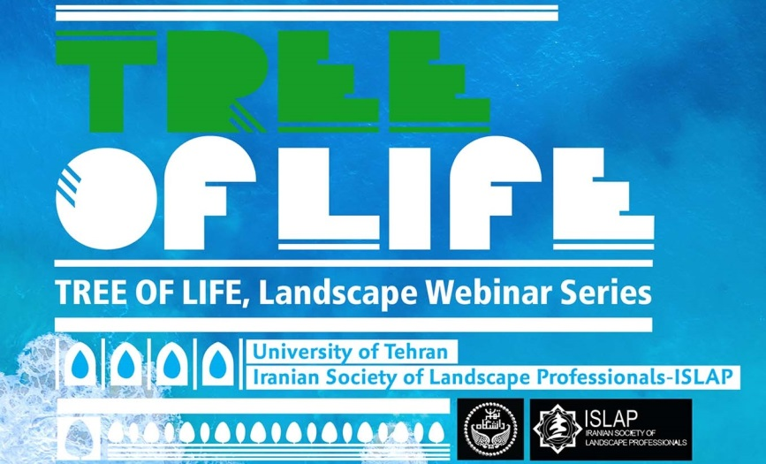

The University of Tehran and the Iranian Society of Landscape Professionals (ISLAP) are pleased to announce the second and the third **TREE of LIFE Landscape Webinar Series**. The webinar series is a joint effort aiming to examine the complex human-natural systems through the lens of landscape approach.

Scheduled for the **21st** and **24th of February 2021**, the second and third packages of the TREE OF LIFE webinars will focus on **Garden Tourism and Garden Festivals**, and **Water, City and Landscape** respectively. Please see the posters and read following lines for further details.

On February 21st, 2021 at 13:30-15:30 UTC, **Professor Richard Benfield** from Central Connecticut State University discusses Garden Tourism for Landscapes, Historic Sites and Visitors: Marrying the Three for the Post-Covid Period and **Professor Karl H. C. Ludwig** from University of Nuertingen-Geislingen will talk about Garden Festivals: Temporary Garden Art and Events, Ephemeral Garden and Art Installations across Europe.

For the 2nd TREE of LIFE Landscape Webinar Series, register at: <https://b2n.ir/treeoflife2>

On February 24th, 2021 at 13:30-15:30 UTC, **Dr. Jianbin Wang**, Chief Innovation Officer at Cooperative Research Centre (CRC) for Water Sensitive Cities in Australia will talk about Future Water Sensitive Cities and **Dr. Sharon Moran** from State University of New York (SUNY), College of Environmental Science and Forestry (ESF) will discuss Urban Waterway: Stream Restoration and Environmental Justice, followed by a presentation on Urban Water Reclamation and Reuse as a Key Water-Energy-Food Nexus Opportunity by **Dr. Daphne Keilmann-Gondhalekar** from Technical University of Munich.

For the 3rd TREE of LIFE Landscape Webinar Series, register at: <https://b2n.ir/treeoflife3>

There will be a live Q&A session at the end of each session of the webinars. Check your local time for the webinars: <https://www.worldtimeserver.com/>

Please feel free to contact us via email [tolwebseries@gmail.com](mailto:tolwebseries@gmail.com) if you require any further information and share the webinar information with friends and colleagues who may be interested to join these online events.